2025_05_23

**Coupled Endothelial and Smooth Muscle Cell Model**

* The EC component (4) and SMC components (1,2,3) are coupled.
* **The involved and edited CellML Models:**

1. Main_Coupled_SMC_Model.cellml
2. **Intracellular_Calcium_SMC.cellml**
3. NO_cGMP_Signalling_SMC.cellml
4. Coupled_Main_EC_Model.cellml
5. EC_SMC_Units.cellml

Notes.

1. In the file Intracellular Calcium_SMC.cellml, agonist effect (level) is considered zero.
2. In the file Intracellular Calcium_SMC.cellml, I digitised the cytosolic calcium concentration [Ca2+]i graph from Figure 4(A) in reference [6] (experiment 5) and used it to generate a step-function input (as below) that mimics the observed pattern. This step function was then used as an input in this model and the coupled model.
3. The [Ca2+]i initial value is changed from 0.116477 uM to 0.05 uM because the study [6](exp 5) noted that during the initial transients of [Ca2+], the calibration may be inaccurate due to inhomogeneities in [Ca2+] during rapid Ca2+ fluxes. So, we chose an initial value close to the [Ca2+] initial value (0.034 uM) in Figure 3 in [6].

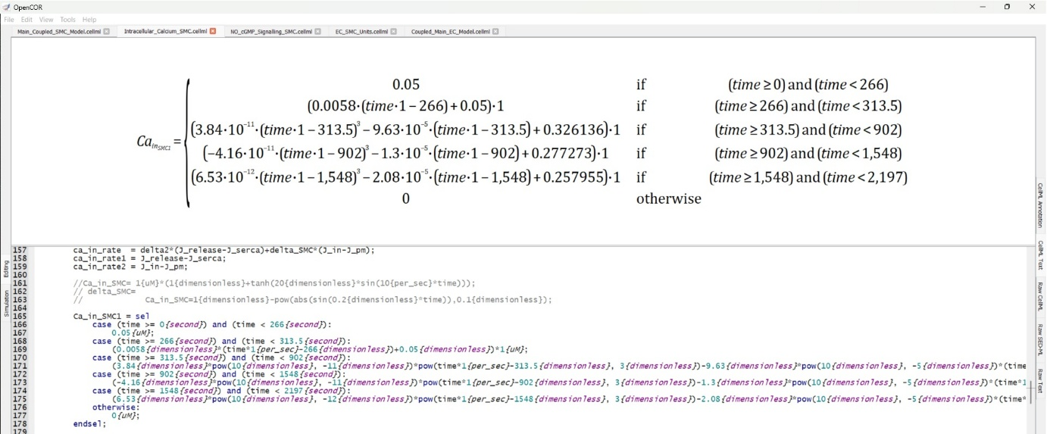

1. Parameters values were changed from the airway setting to lung arteriole setting from Table 1 in [4].

References:

1. Hai, C. M., & Murphy, R. A. (1988). Cross-bridge phosphorylation and regulation of latch state in smooth muscle. *American Journal of Physiology-Cell Physiology*, *254*(1), C99-C106.
2. Sriram, K., Laughlin, J. G., Rangamani, P., & Tartakovsky, D. M. (2016). Shear-induced nitric oxide production by endothelial cells. *Biophysical journal*, *111*(1), 208-221.
3. Wang, I. Y., Bai, Y., Sanderson, M. J., & Sneyd, J. (2010). A mathematical analysis of agonist-and KCl-induced Ca2+ oscillations in mouse airway smooth muscle cells. *Biophysical journal*, *98*(7), 1170-1181.
4. Wang, I., Politi, A. Z., Tania, N., Bai, Y., Sanderson, M. J., & Sneyd, J. (2008). A mathematical model of airway and pulmonary arteriole smooth muscle. *Biophysical journal*, *94*(6), 2053-2064.
5. Yang, J., Clark, J. W., Bryan, R. M., & Robertson, C. S. (2005). Mathematical modeling of the nitric oxide/cGMP pathway in the vascular smooth muscle cell. American Journal of Physiology-Heart and Circulatory Physiology, 289(2), H886-H897.
6. Rembold, C. M., & Murphy, R. A. (1988). Myoplasmic [Ca2+] determines myosin phosphorylation in agonist-stimulated swine arterial smooth muscle. *Circulation research*, *63*(3), 593-603.